**Experiment -2.3**

**Student Name: Parikshit sharma UID: 19BCS4520**

**Branch: BE CSE(IOT) Section/Group: IOT 1/A**

**Semester: 4TH Date of Performance: 11/03/2021**

**Subject Name: PBLIJ Subject Code: CSP 296**

**1. Aim/Overview of the practical:**

Write a Java multi threaded program to implement the tortoise and hare story. Make the hare sleep at the mid of the way and let the tortoise win.

**2. Task to be done:**

In this program we try to implement tortoise and hare story in java by using the concept of multi threading.

**3. Apparatus(For applied/experimental sciences/materials based labs):**

Laptop/PC, installed JDK, internet connectivity, eclipse etc.

**4. Algorithm/Flowchart (For programming based labs):**

Step1Creating an object of the tortoise  thread

Step2 Starting the first thread

Step 3 hare going to sleep

Step 4 hare wakes up

Step 5 tortoise won

Step6 exit

**5. Theme/Interests definition( For creative domains):**

**Multithreading in Java:**

Multithreadingin Java is a process of executing two or more threads simultaneously to maximum utilization of CPU. Multithreaded applications execute two or more threads run concurrently. Hence, it is also known as Concurrency in Java**.**

**6. Steps for experiment/practical:**

/*

* To change this license header, choose License Headers in Project Properties.

* To change this template file, choose Tools | Templates

* and open the template in the editor.

*/

package thread_ex2.pkg3;

/**

*

* @author dell

*/

public class Thread_ex23 {

/**

* @param args the command line arguments

*/

public static void main(String[] args) {

// TODO code application logic here

Thread tortoise = new Tortoise();

tortoise.start();

for(int a=1;a<20;a++)

{

System.out.println("Distance covered by HARE = "+(a));

}

System.out.println("*****************************HARE IS GOING TO SLEEP*******************************"); //hare going to sleep

try

{

Thread.sleep(3000); // current thread is hare

}

catch(InterruptedException ie)

{

}

System.out.println("***********************************HARE AGAIN STARTED THE RACE **********************************************"); //hare wakes up

for(int b=11;b<21;b++)

System.out.println("Distance covered by HARE = "+(b));

System.out.println("***********************************HARE HAS COMPLETED THE RACE*******************************************************");

}

}

class Tortoise extends Thread

{

@Override

public void run()

{

for(int c=1;c<30;c++)

{

System.out.println("Distance covered by TORTOISE = "+c);

}

System.out.println("*****************TORTOISE HAS WON THE RACE*******************"); // tortoise won the race

}

}

**7. Observations/Discussions(For applied/experimental sciences/materials based labs):**

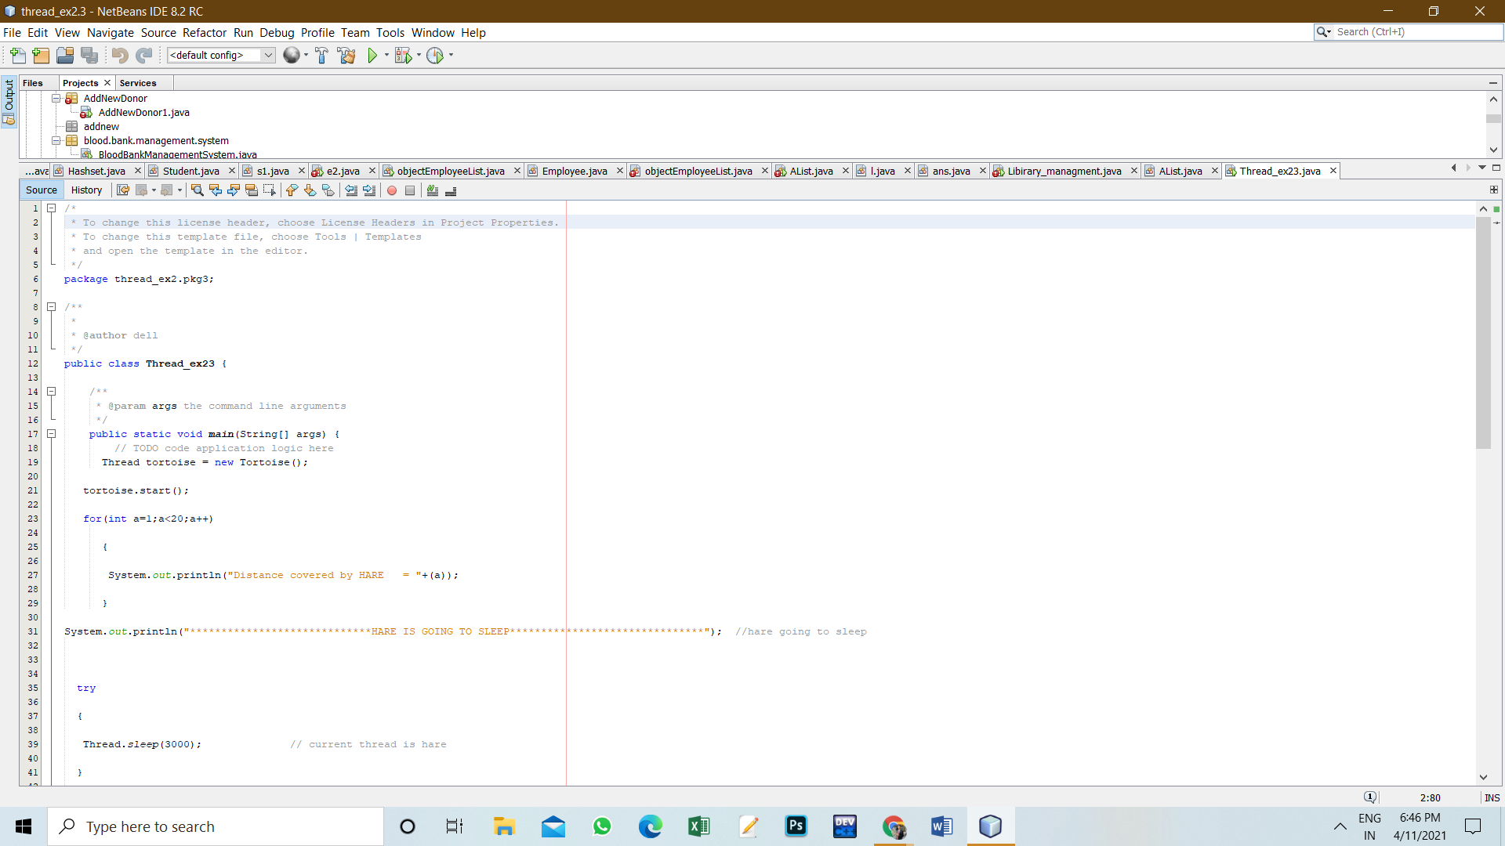

**8. Percentage error (if any or applicable):**

NA

**9. Calculations/ Chemical Reactions / Theorems /Formulas used etc :**

NA

**10. Result/Output/Writing Summary:**

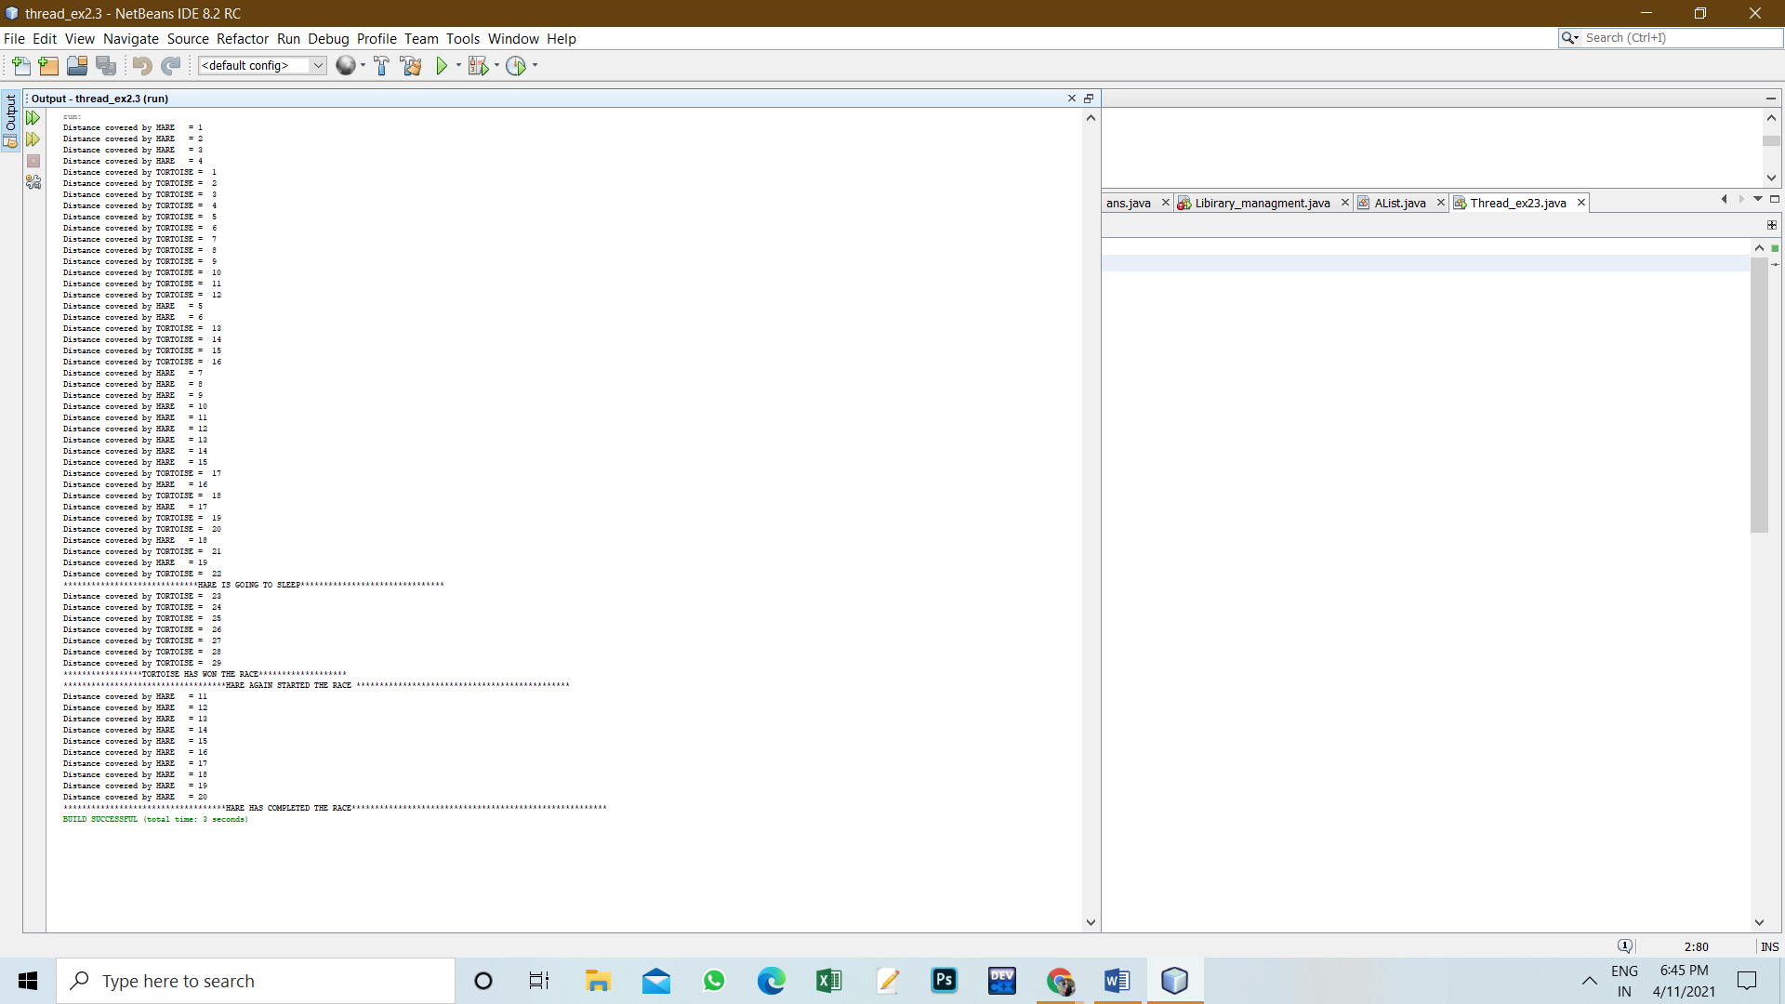

**11. Graphs (If Any): Image /Soft copy of graph paper to be attached here**

NA

**Learning outcomes (What I have learnt):**

1. Learn about the concept of multithreading.

2. Learn about various operation through multithreading.

3. Learn about writing effective program.

**Evaluation Grid (To be created as per the SOP and Assessment guidelines by the faculty):**

|  |  |  |  |
| --- | --- | --- | --- |
| Sr. No. | Parameters | Marks Obtained | Maximum Marks |
| 1. |  |  |  |
| 2. |  |  |  |
| 3. |  |  |  |
|  |  |  |  |